**UNIX COMMANDS**

**Tar**

tar is to simply combine a few files into a single file, for easy storage and distribution.

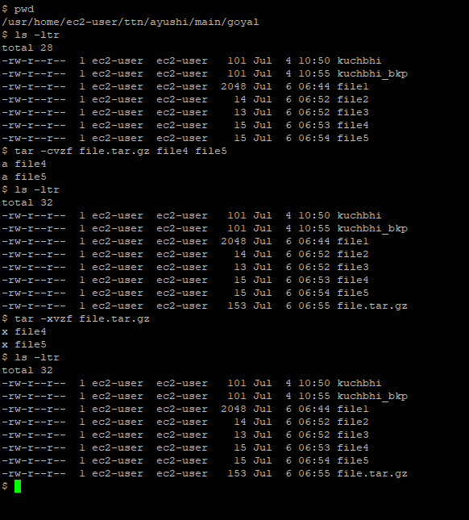

* **z:** option tells **tar** to zip the archive as it is created.
* **x:** (**extract**) in present working directory
* c: **Creates a new .tar archive file.**
* **v: In create and extract modes, tar will list each file name as it is read from or written to the archive. In list mode, tar will produce output similar to that of ls(1).f Read the archive from or write the archive to the specified file.**

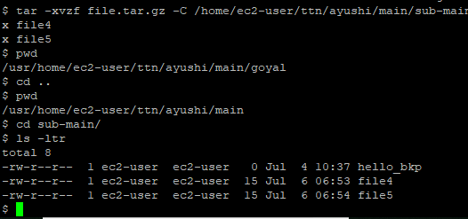

* C: untar in a different directory.

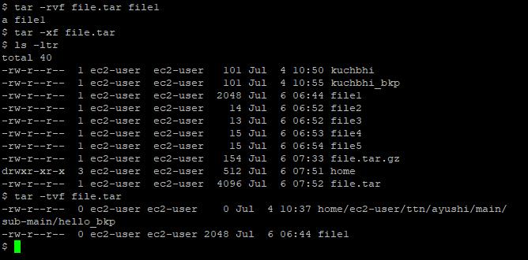

* r: add file named file1 to existing file.tar

**Find : Search for a file; walk through file heirarchy**

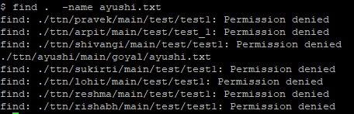

Find (.) search the specified file within current directory and sub directory.

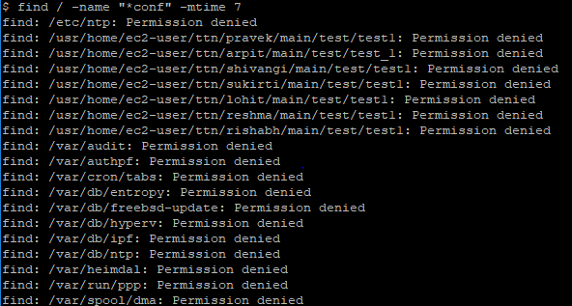

Above command returns a list of all files in the entire file system that end with the characters conf and have been modified in the last 7 days.

**Locate** : The locate program searches a database for all pathnames which match the specified pattern.

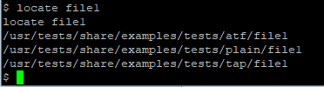

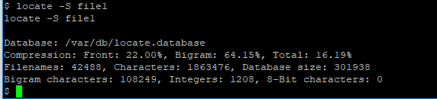

Above command –S return stats of a file.



Above command -0 formats output separated by ASCII character rather than new line.

**DIFF:**

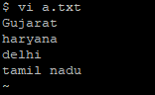 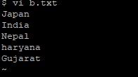

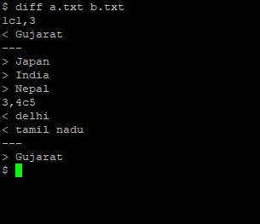

* Lines preceded by a **<** are lines from the first file.
* Lines preceded by **>** are lines from the second file.
* Next line contains 3**,4c5** which means from line 3 to line 4 in the first file needs to be changed to match line number 5 in the second file.

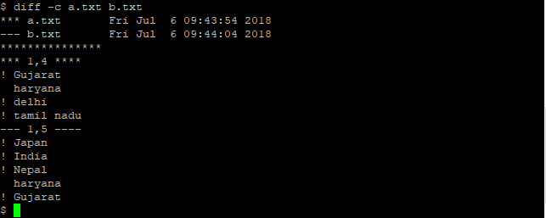

Shows context mode.

**+ :** It indicates a line in the second file that needs to be added to the first file to make them identical.  
 **– :** It indicates a line in the first file that needs to be deleted to make them identical.

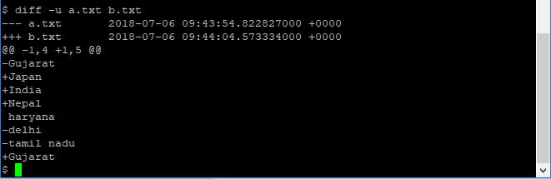

-u options enables unified mode. It **doesn’t display any redundant information** or it shows the information in concise form.

**TAIL:**

Prints the last N number of data of the given input. By default it prints the last 10 lines of the specified files.

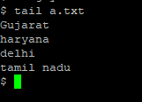

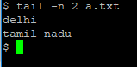

-n: specify number of last lines to be displayed.

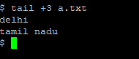

+ : prints the data starting from specified line number of the file instead of end.

**LESS :**

command is used to view files instead of opening the file.

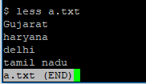

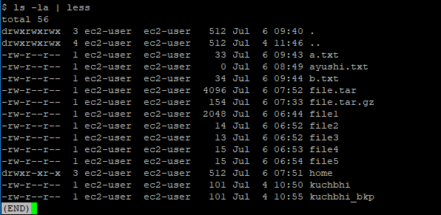

To see large outputs one-screen-full at a time (command | less).

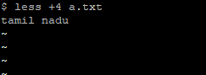

 To Starts up the file from the given number(less +number file_path).

**Ln :** creates a hard link just like link does.

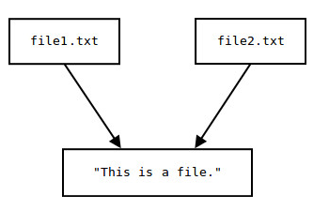

I am at TTN

Ttn1.txt

Ttn2.txt

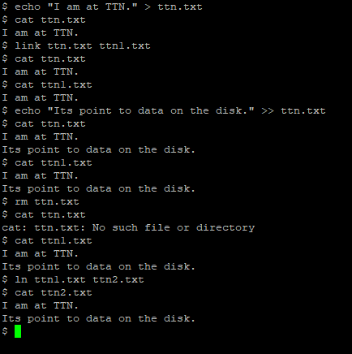

**Ln –s:** create symbolic links

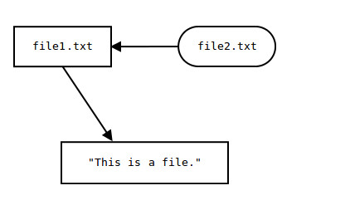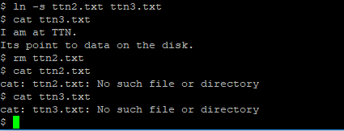

I am at TTN.

Ttn2.txt

Ttn3.txt